Practical no 10

* **Exploiting with Metasploit (Kali Linux)**

Open kali linux in virtual machine

Passing the git clone url and change the directory using cd hoaxshell and then installing requirements.txt

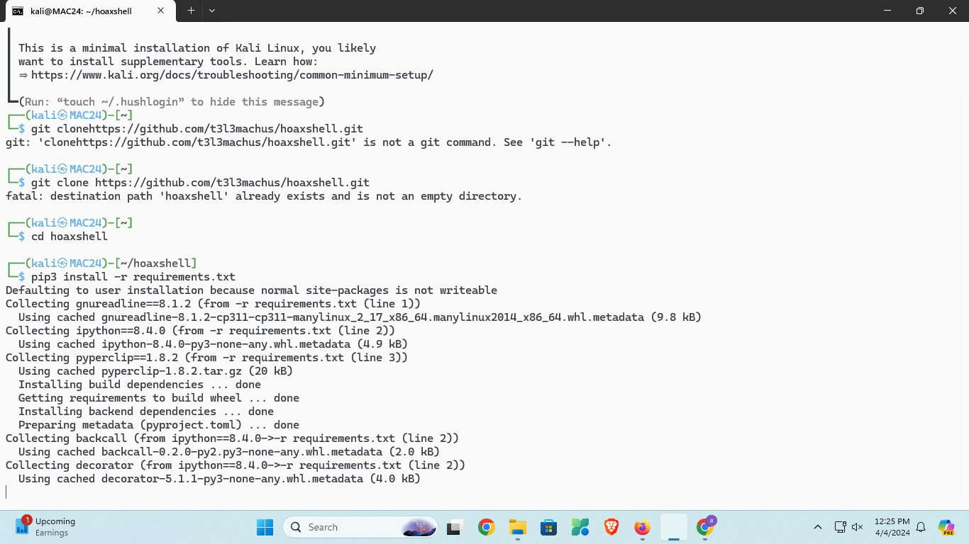

Check th ip using ifconfig command

Copy the inet of eth0

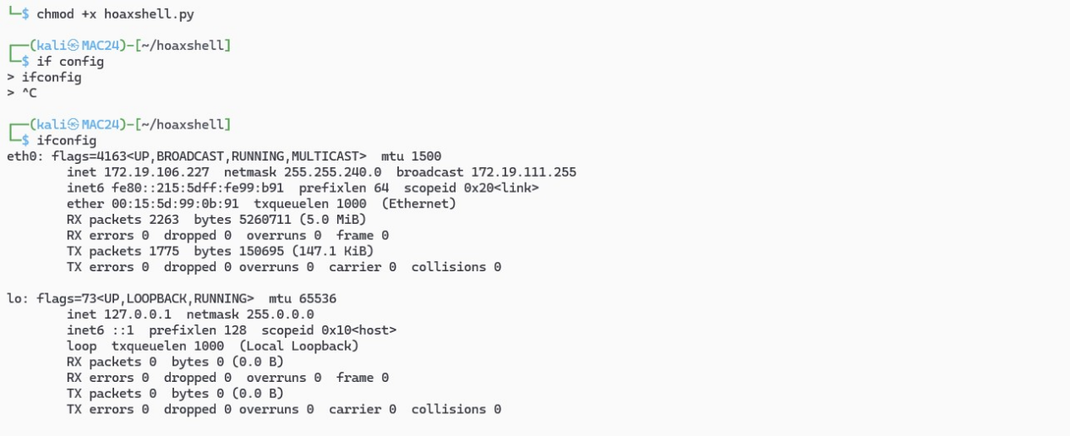

Type following command

Python3 hoaxshell.py -s <paste your copied ip here >

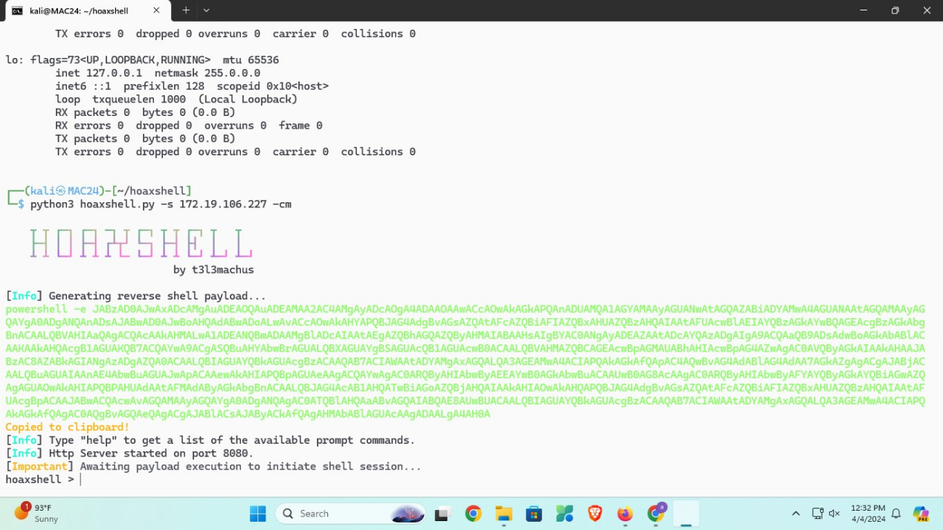

Here generated the payload

Paste this payload into windows powershell

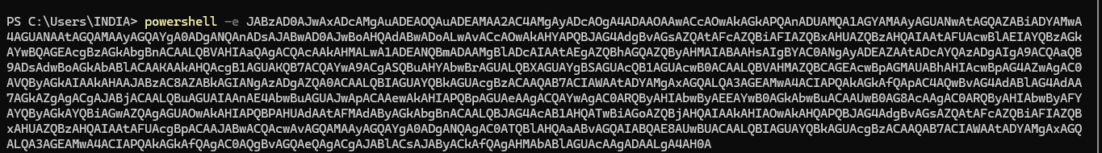

After that our powershell open in kali linux

Here we get the date

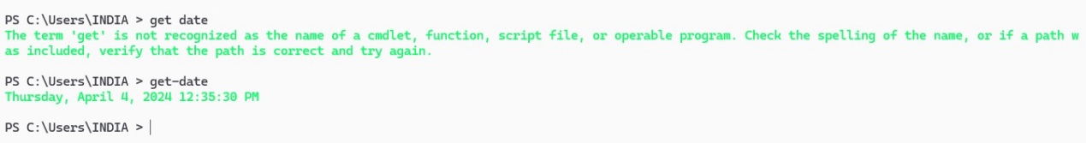

Checking desktop there is no practical folder on desktop

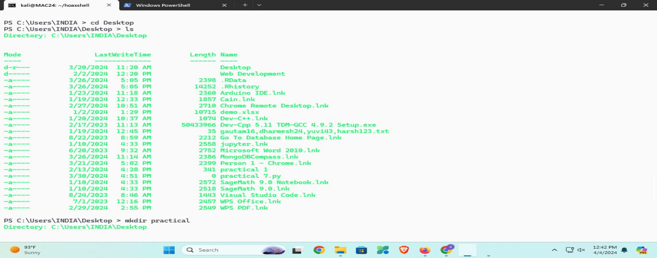

Then creating one folder on desktop

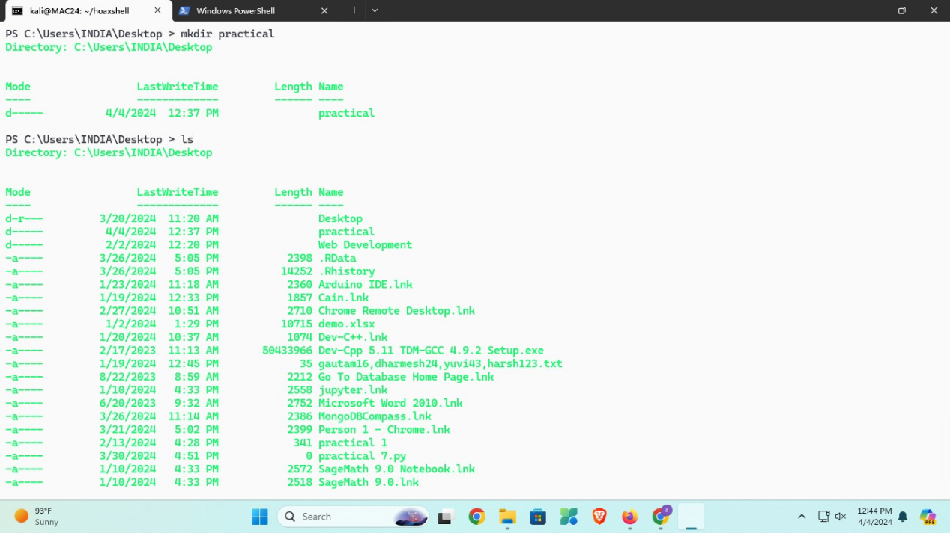

Here we can see practical folder on our desktop